Christopher Hand to Healthy Food Cookbook

5/26/2012
Christopher Di Marco

Got some recipes from the complete book of raw food
In this cookbook you will see lots of tasty, healthy recipes. Like lemonade and ice tea with stevia instead of sugar, stevia is a heather sweetener because it has 0 calories, it is natural and it is 0 on the glycemic index. I also have made kale chips witch taste good and is healthier than regular potato chips.

Drinks

Ice tea

Ingredients
- Black tea
- 2 quarts water
- 10 packets Sweet Leaf Stevia®

Directions
Bring two quarts water to a boil; remove from burner immediately. Add black tea and steep for 10 minutes. Remove tea and cool. Pour into glass pitcher and stir in 10 packets SweetLeaf Stevia® Sweetener. Stir until sweetener has dissolved. Let cool. Sweetened tea is more perishable than unsweetened – store it well-sealed in a glass (not plastic) container in the refrigerator.

The Best Lemonade -heathy, easy and sweetened with stevia
Make sure you do not use the spoonable type of stevia, but the concentrated type. You can also use limes for a “limade” which is also very good.
1 cup of freshly juiced lemon juice (usually 4-6 lemons)
1/2 to 1 teaspoon of stevia (or more, to taste)
6 cups of water
Combine, adjust sweetness with stevia (start low and build up) chill and serve over ice, if desired. It’s as simple and easy as that!

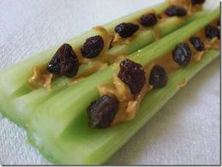

Snacks

Ants on a log

Ingredients
Celery, almond butter, raisins

Directions
Cut celery into “logs.” Spread raw almond butter into the celery logs. Put the “ants,” or raisins, oonto the log and enjoy!

Kale chips

Ingredients
- 1 bunch kale
- 1 tablespoon olive oil
- 1 teaspoon seasoned salt

Directions
- Preheat an oven to 350 degrees F (175 degrees C). Line a non insulated cookie sheet with parchment paper.
- With a knife or kitchen shears carefully remove the leaves from the thick stems and tear into bite size pieces. Wash and thoroughly dry kale with a salad spinner. Drizzle kale with olive oil and sprinkle with seasoning salt.
- Bake until the edges brown but are not burnt, 10 to 15 minutes.

Romaine roll-ups
Serves 2

Ingredients
1 large head of romaine lettuce, 3 large tomatoes, finely chopped, 1 avocado, peeled, pitted, and finely chopped, 1 handful alfalfa sprouts, 2 tablespoons fresh cilantro, finely chopped, basil, oregano or mint, finely chopped, onion and/or garlic, finely chopped (optional)

Directions
Separate the leaves of the romaine and place on a plate. In a bowl, mix together the tomatoes, avocado, alfalfa, cilantro, basil, oregano or mint, onion and garlic (if using) to make the filling. Spoon a generous dollop of the filling at one end of each lettuce leaf. Roll the side of the leaf over, fold it in half. Continue until you have used all the filling and then eat like a sandwich.

Main curses
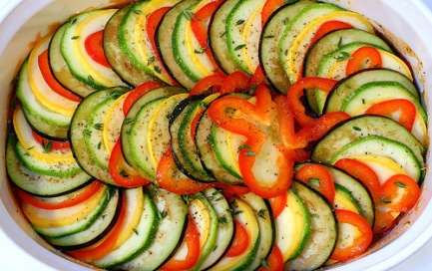

Raw ratatouille

Ingredients
1 avocado, peeled, pitted and chopped 2 tomatoes , chopped ¼ cup chopped cilantro 2 cloves garlic, peeled and chopped 1 squash, chopped
Sauce
1 tablespoon tahini, 1 tablespoon honey, celtic sea salt, to taste

Directions
Combine the avocado with the tomatoes ,cilantro, garlic and squash in a large bowl
Mix the tahini and honey together¸ adding sea salt to taste. Pour the dressing over the vegetables.
Serve immediately or chill in the refrigerator.

Tomato sauce

Ingredient

6 sun dried tomatoes, soaked 2 hours minimum
2 cups chopped fresh tomatoes
10 basil leaves
4 medjool dates, soaked 2 hours minimum
Pinch paprika
1 red pepper, seeds and core remover

Directions
Using a hand blender, blend all the ingredients until smooth. The sauce will keep for two days in the fridge if you cover it.

Soft Tacos
Serves 2 need food processor

Ingredients
For the filling:
3 cups ground raw organic walnuts, 1 teaspoon organic cumin seed powder, 1 teaspoon organic coriander seed powder, 1/3 cup nama shoyu
For the salsa
3 cups organic tomatoes, chopped, ½ cup chopped organic green and yellow onions, ¼ cup fresh, organic lime or lemon juice, 1 organic bell pepper, chopped, 1cup fresh organic cilantro, chopped with stems removed, ¼ cups organic cold- pressed olive oil, 3 cloves organic garlic, peeled and crushed or minced, organic cayenne powder to taste, ½ teaspoon celtic sea salt, 1 teaspoon organic cumin seed powder
For the taco shell
Organic collard green leaves
For the topping
Organic romaine lettuce, shredded 1 avocado, cubed

Directions
To make the taco filling, combine the filling ingredients in a bowl and mix well. In another bowl, combine the salsa ingredients and mix well. To assemble the tacos, lay the collard green leaves flat. Spread the taco filling lengthwise. Add a layer of lettuce and top with the salsa and avocado.

Deserts

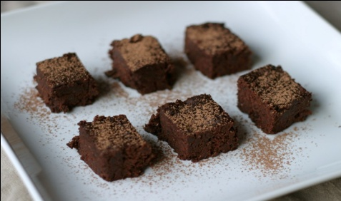RAW BROWNIE BITES

Ingredients (makes about 24 bites)
- 2 cups of raw walnuts (or other nut)
- 2 1/2 cups of Medjool dates, pitted (about 16 dates)
- 1 cup of raw cacao (I used organic raw cacao, gifted to me by More Than Alive; you can substitute regular cocoa if you don’t have raw)
- 1/4 teaspoon of sea salt
- 1/2 teaspoon of vanilla extract, or 1/8 teaspoon of vanilla bean powder (optional)
Tip: This recipe is easy to cut in half if you want a smaller batch of brownies.

Method
- Using a food processor, process the nuts until they are the consistency of nut flour.
- Add the cacao and sea salt to the walnut flour and pulse to blend well.
- Optionally, add the vanilla extract or powder and pulse again to blend well.
- Add one date at a time to the mixture through the feed tube on the processor. Don’t add too many dates – just enough so the batter resembles cake crumbs, but when pressed between your fingers, it sticks together. The more dates you add, the better it will stick together, but the denser the brownie will be. I prefer them lighter, so I use the smallest amount of dates necessary to get the batter sticking together.
- Empty the batter into a dish (I use a square 8 by 8 inch dish), and press down evenly.
- Place in the refrigerator for about 10 minutes, and then slice them into cubes with a knife. They are easier to slice when a bit cold. Store cold, or at room temperature.

Raw candy
Makes ten

Ingredients
10 dates and 10 almonds

Directions
Pit the dates; insert an almond into the pit hole of each date

